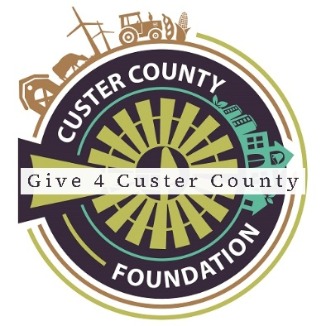

Dear <NAME>,

We wanted to let you know that (**NONPROFIT NAME HERE)** is proud to be participating in **GIVE 4 CUSTER COUNTY**, an event to grow philanthropy. **GIVE 4 CUSTER COUNTY** inspires communities to come together to give as much as possible to support the work of nonprofits in Custer County.

This giving event takes place June 16th – June 30th. Please mark your calendars because we need your help! We will be joining 42 other local nonprofits to raise money together and compete for matching funds and prize money.

**(TELL ABOUT YOUR NONPROFIT AND THE WORK YOU DO LOCALLY)!**

Please consider making a donation during **GIVE 4 CUSTER COUNTY** to help support our work. You can donate online by going to <https://give4cc.asimobile.net/#/index> and search for **(YOUR NPO G4CC PAGE.)** Donations may also be dropped off at the Custer County Foundation office. Checks must be made payable to the Custer County Foundation and dated between June 16th and June 30th. Please put **(YOUR NPO NAME)** in the memo line.

For more information, visit: [www.custercountyfoundation.org/give4custercounty](http://www.custercountyfoundation.org/give4custercounty)

We are grateful for your support and generosity!

Sincerely,