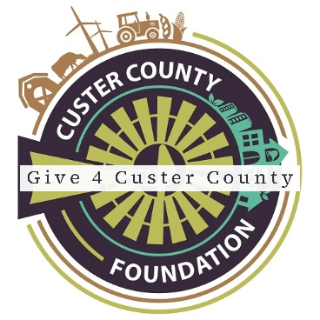

**Sample Posts and Tweets**

Remember, when posting on social media, a picture truly is worth a thousand words! Post pictures of prepping for your fundraising event (i.e. setting up tables, stuffing envelopes), pictures during the event, group photos, etc. Also, everyone affiliated with your organization needs to “Like” and share your posts. The more views your posts get, the better your chances of a successful donation!

* GIVE 4 CUSTER COUNTY is (insert the number of days until June 16th ) away! Join us for this Giving Event! Visit CusterCountyFoundation.org and select GIVE 4 CUSTER COUNTY under the Giving tab.
* (Enter your organization name) is participating in GIVE 4 CUSTER COUNTY! This Giving Event is an effort to help our Custer County nonprofits! Visit CusterCountyFoundation.org and click on GIVE 4 CUSTER COUNTY under the Giving tab.
* GIVE 4 CUSTER COUNTY! Be a part of the giving! Visit CusterCountyFoundation.org and click on GIVE 4 CUSTER COUNTY under the Giving tab.
* GIVE 4 CUSTER COUNTY is an additional way to give to local nonprofit organizations in Custer County. Join the giving TODAY! Visit CusterCountyFoundation.org and click on GIVE 4 CUSTER COUNTY under the Giving tab.
* The time has come! GIVE 4 CUSTER COUNTY STARTS TODAY! To give to (Insert your organization name), click the link below! Give4cc.asimobile.net
* Join us TODAY at (time) for our (insert your promotional event here)! Support GIVE 4 CUSTER COUNTY today! Visit give4cc.asimobile.net to see how you can GIVE 4 CUSTER COUNTY! (DON’T FORGET YOUR PHOTOS!!!)
* Together, let’s Give 4 Custer County! Visit our link at Give4cc.asimobile.net.
* (Insert your organization name) is participating in GIVE 4 CUSTER COUNTY! Click the link to make a difference! Give4cc.asimobile.net

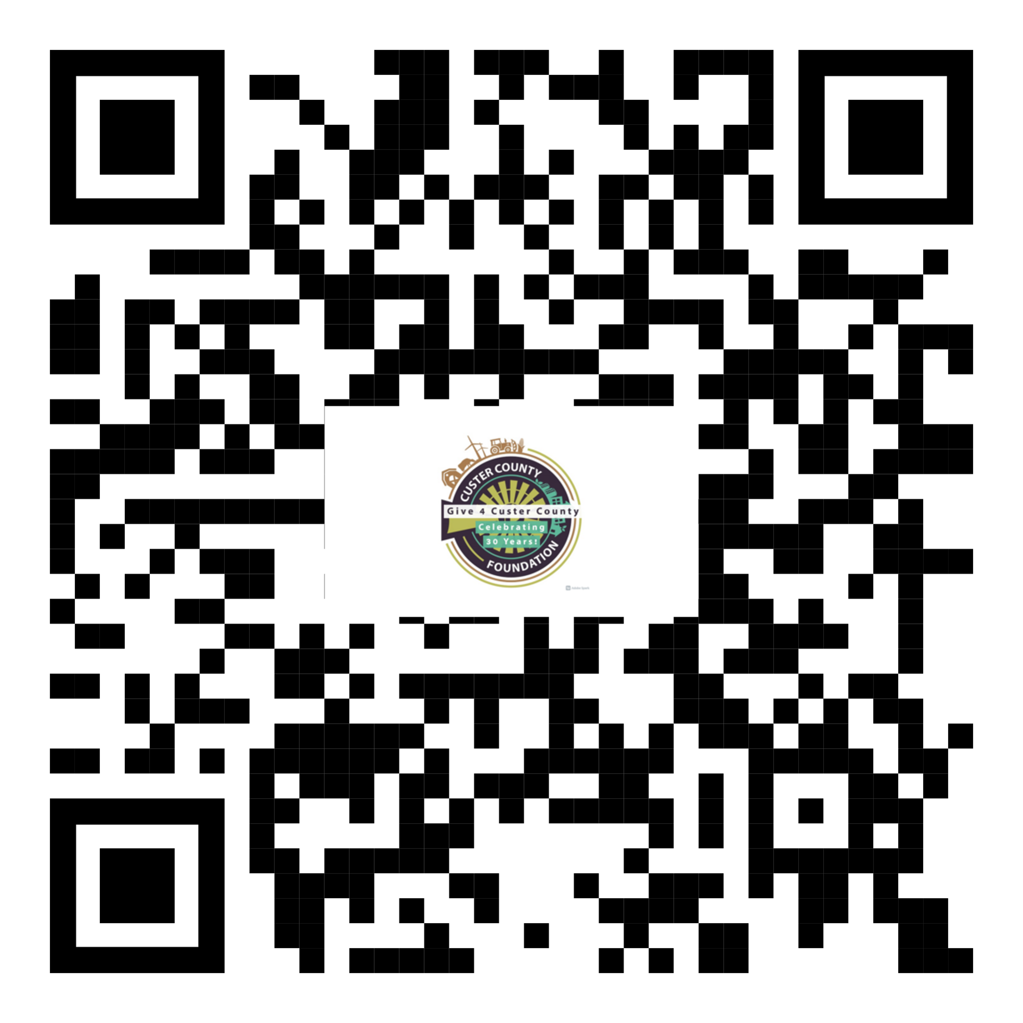

Insert this QR code on all marketing materials to allow for easy access to the donation website.