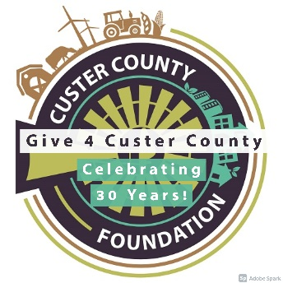
Sample Posts and Tweets

Remember, when posting on social media, a picture truly is worth a thousand words! Post pictures of prepping for your fundraising event (i.e. setting up tables, stuffing envelopes), pictures during the event, group photos, etc.
- GIVE 4 CUSTER COUNTY is (insert number of days July 13th) away! Join us for this Giving Event! Visit CusterCountyFoundation.org and select GIVE 4 CUSTER COUNTY under the Giving tab.

- (Enter your organization name) is participating in GIVE 4 CUSTER COUNTY! This Giving Event is an effort to help our Custer County nonprofits! Visit CusterCountyFoundation.org and click on GIVE 4 CUSTER COUNTY under the Giving tab.

- GIVE 4 CUSTER COUNTY! Be a part of the giving! Visit CusterCountyFoundation.org and click on GIVE 4 CUSTER COUNTY under the Giving tab.

- GIVE 4 CUSTER COUNTY is an additional way to give to local nonprofit organizations in Custer County. Join the giving TODAY! Visit CusterCountyFoundation.org and click on GIVE 4 CUSTER COUNTY under the Giving tab.

- The time has come! GIVE 4 CUSTER COUNTY TODAY! To give to (Insert your organization name), click the link below! Give4cc.asimobile.net

- Join us TODAY at (time) for our (insert your promotional event here)! Support GIVE 4 CUSTER COUNTY today! Visit give4cc.asimobile.net to see how your can GIVE 4 CUSTER COUNTY! (DON’T FORGET YOUR PHOTOS!!!)

- Together, let’s Give 4 Custer County! Visit our link at Give4cc.asimobile.net.

- (Insert your organization name) is participating in GIVE 4 CUSTER COUNTY! Click the link to make a difference! Give4cc.asimobile.net

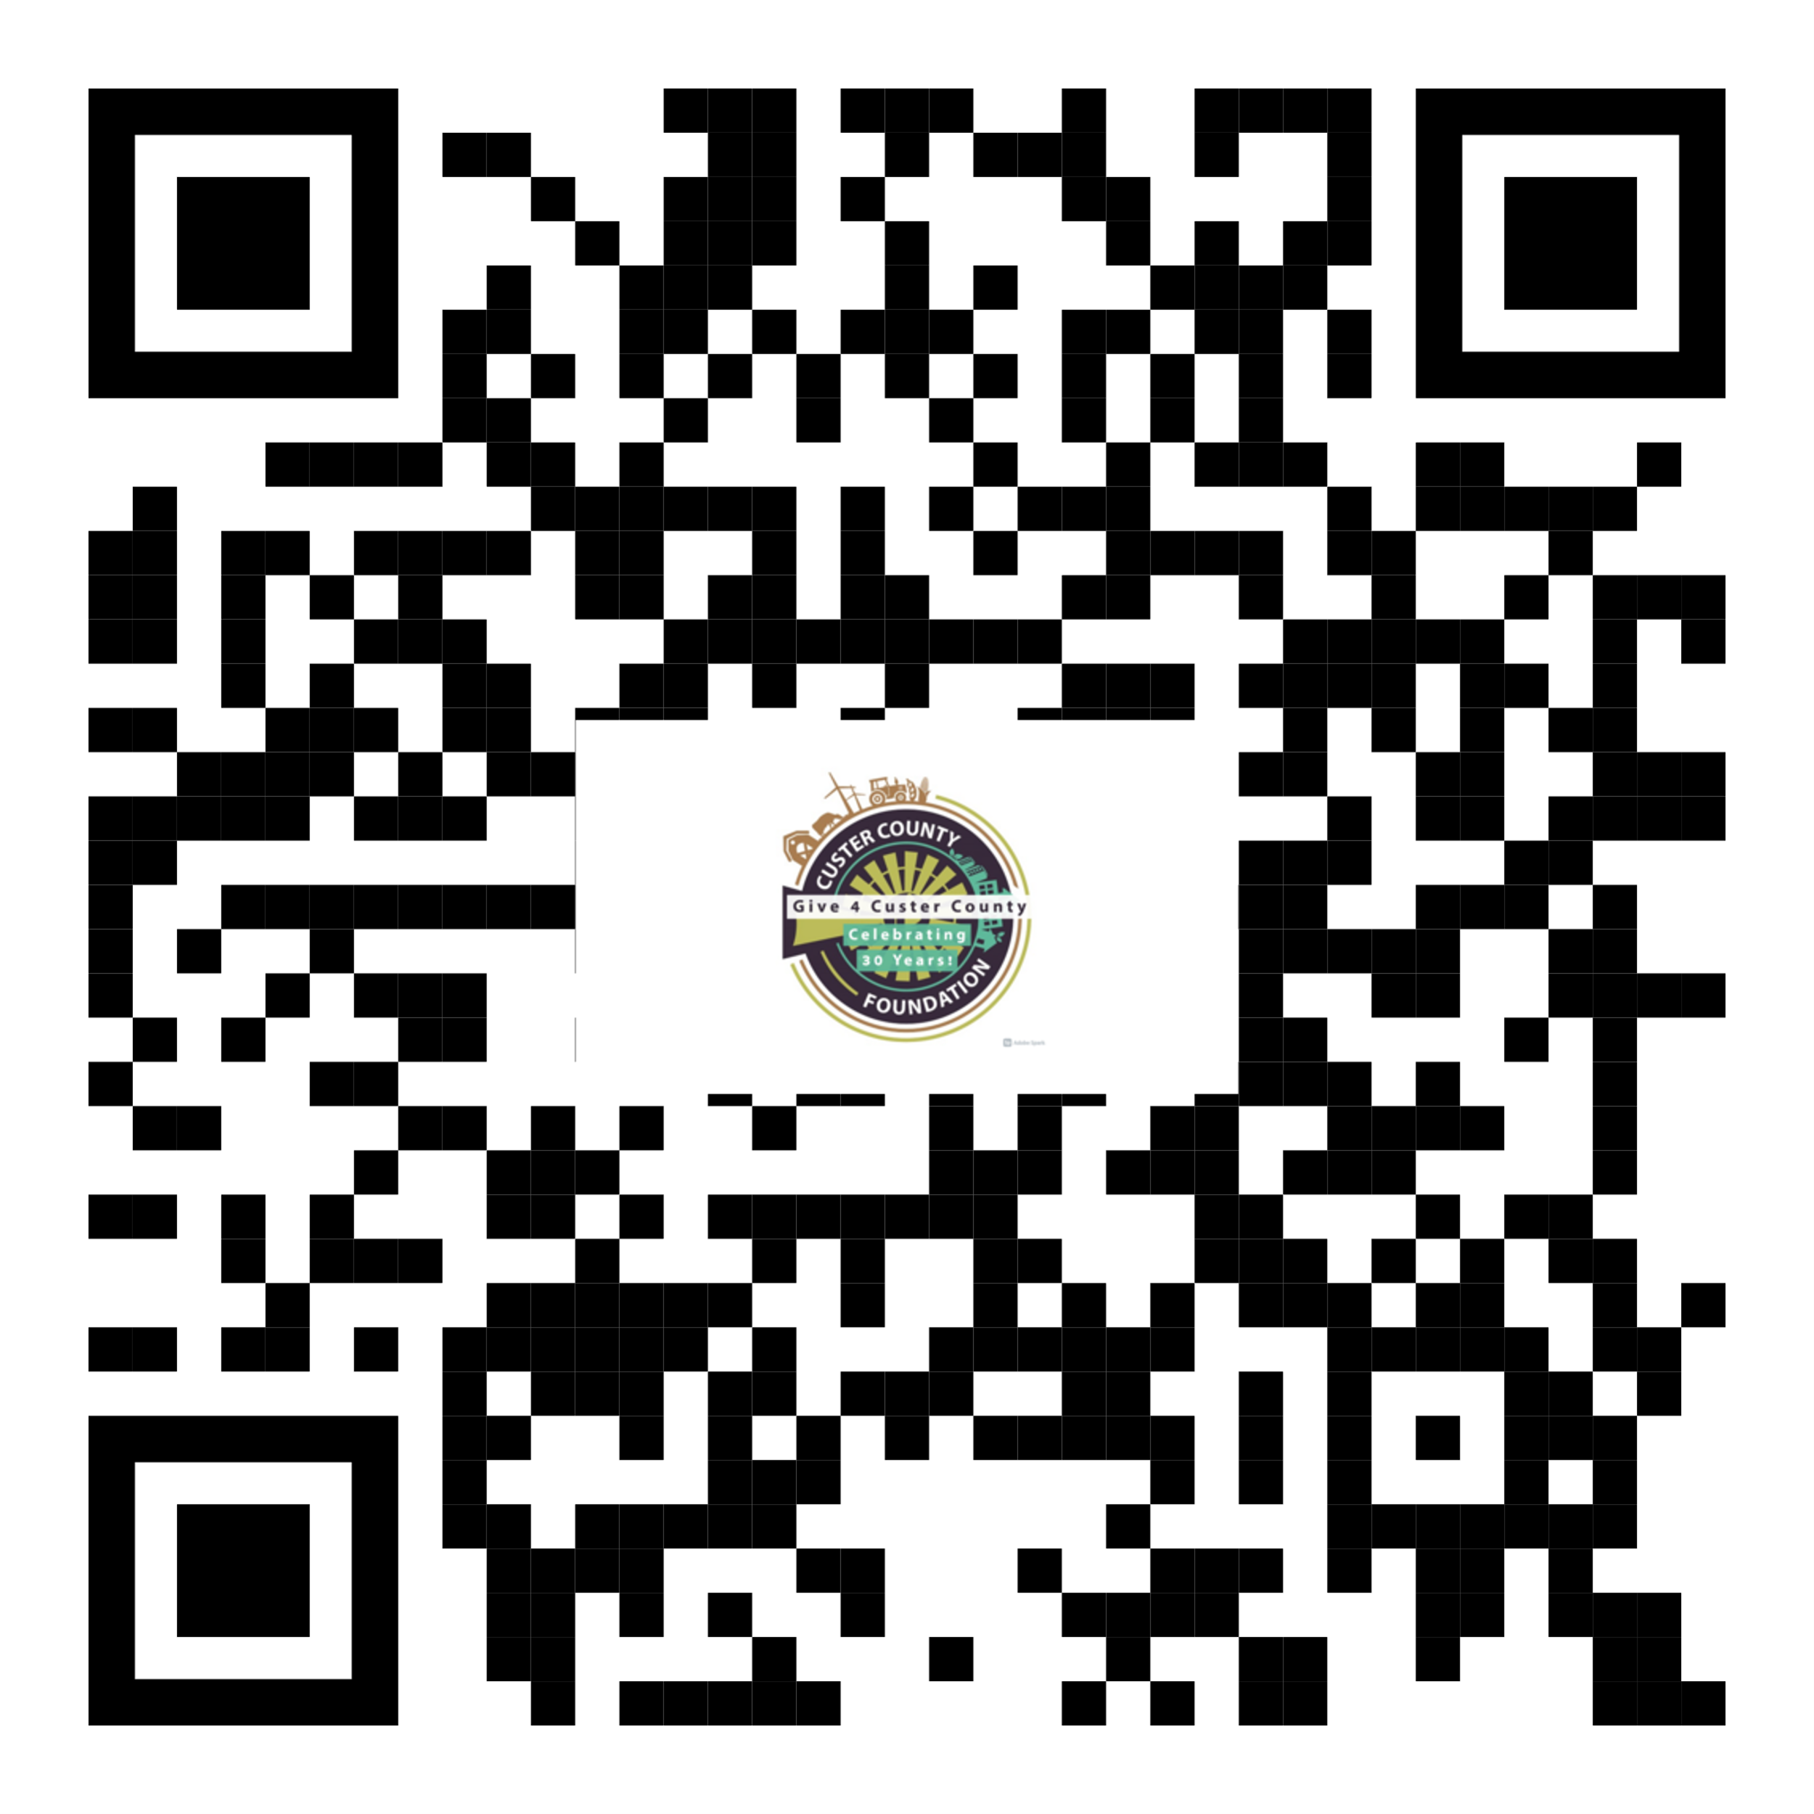

Insert this QR code on all marketing materials to allow for easy access to the donation website.

