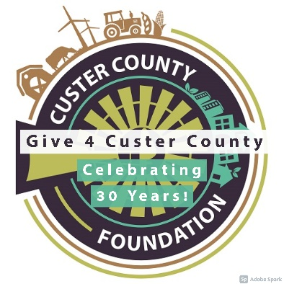

Dear <NAME>,

We wanted to let you know that (NONPROFIT NAME HERE) is proud to be participating in GIVE 4 CUSTER COUNTY, an event to grow philanthropy. GIVE 4 CUSTER COUNTY inspires communities to come together to give as much as possible to support the work of nonprofits in Custer County.

The online giving event takes place July 13, 14, & 15th. Please mark your calendars because we need your help! We will be joining 23 local nonprofits to raise money together and compete for matching funds and prize money.

(TELL ABOUT YOUR NONPROFIT AND THE WORK YOU DO LOCALLY)!

Please consider making a donation during GIVE 4 CUSTER COUNTY to help support our work. If you are busy on July 15th, the day of the big finale, you can submit your donation ahead of time at https://give4cc.asimobile.net/#/index and search for (YOUR NPO GO BIG GIVE PAGE.)

For more information, visit: www.custercountyfoundation.org/give4custercounty

We are grateful for your support and generosity!

Sincerely,

